GIT HOL
LAB -1
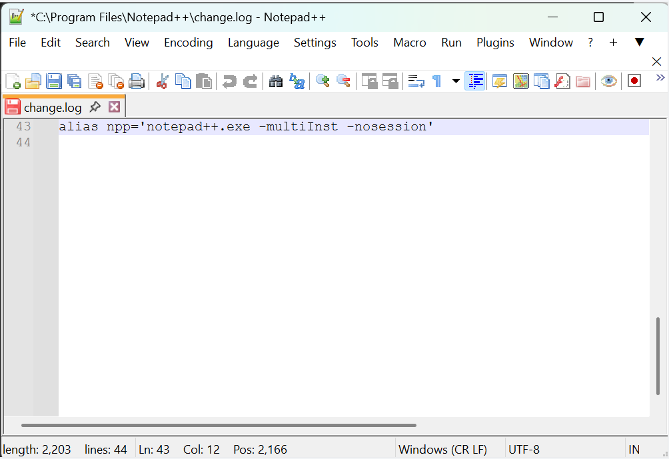
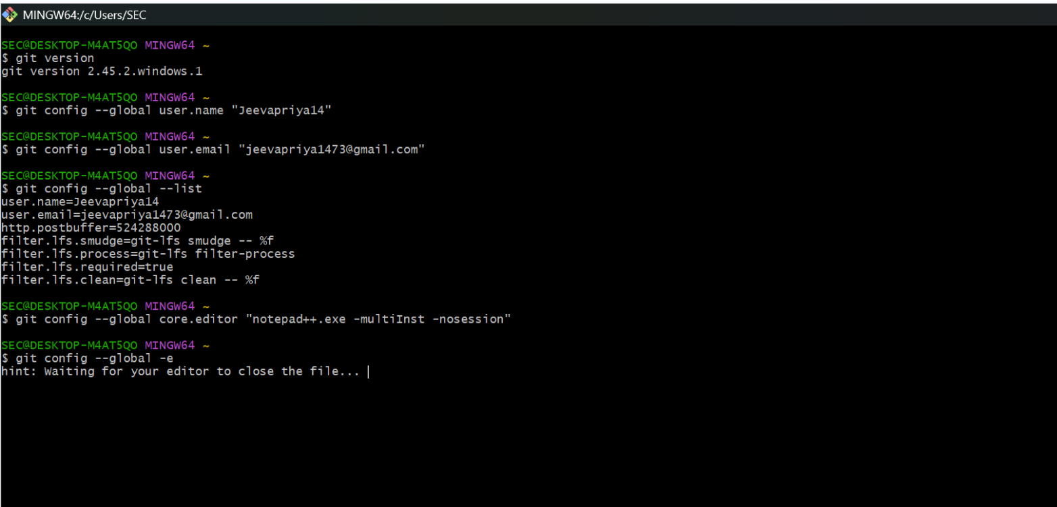
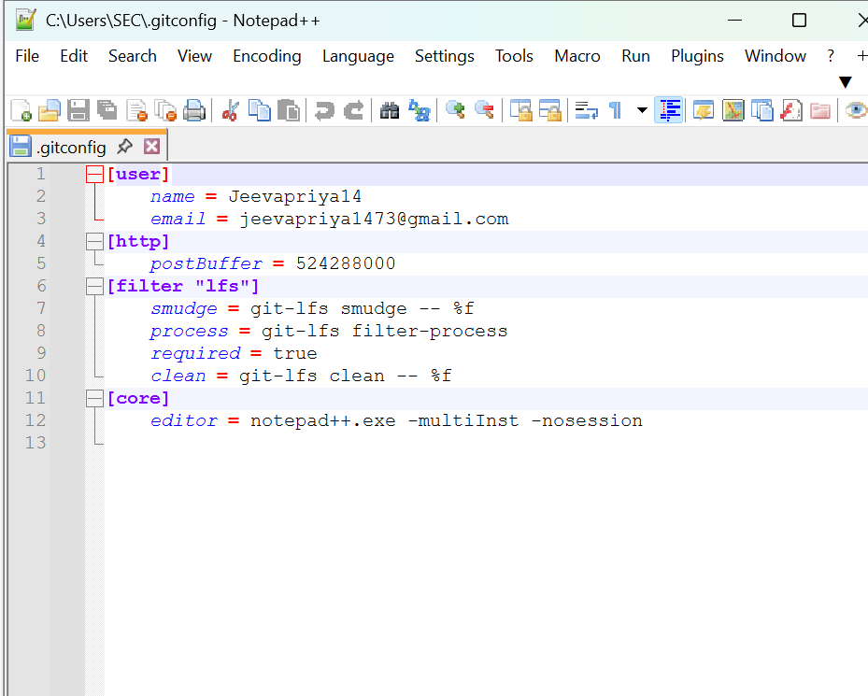
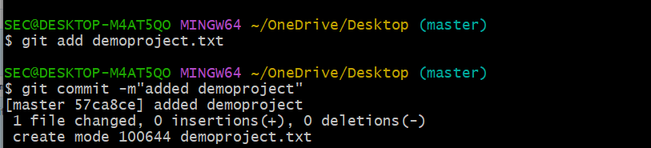
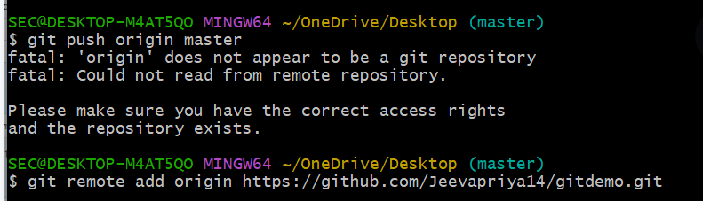
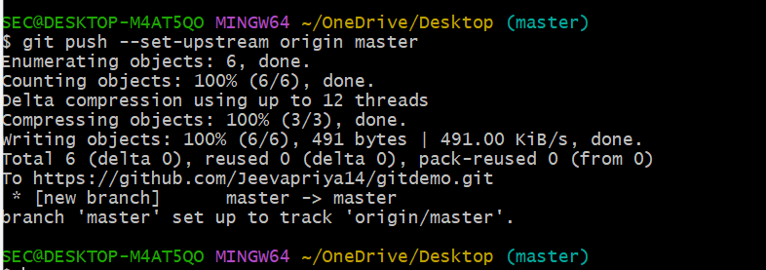
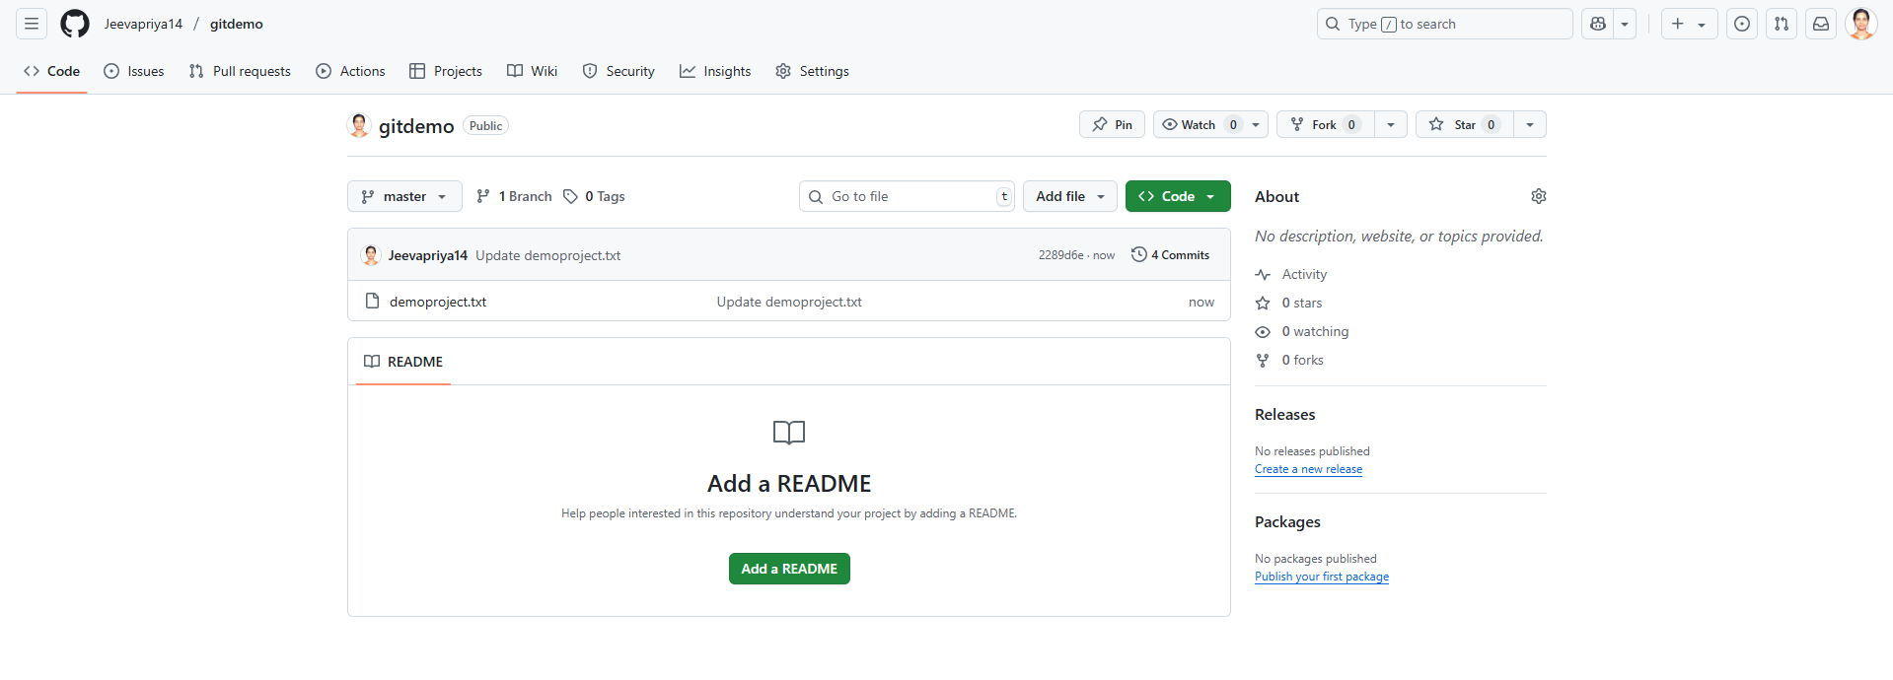
LAB -2
.gitignore is a special file you put in your Git repository root to tell Git which files or folders it should ignore
Why use .gitignore?
-> To avoid committing unnecessary files like logs, build artifacts, temporary files, IDE configs, etc.
-> Keeps your repo clean and avoids pushing sensitive or bulky files to remote.
